

LAB EXPERIMENT RECORD
SET 5: WEBSITE ANALYSIS

Department | Artificial Intelligence and Data Science
Course Code / Course Name | DSA0601 / Data Handling and Visualization
Name / Register Number | BALA VIJAY S / 192424160
Date / Day | 01/10/2026

Aim
To analyze website analytics using the requested visualizations and dashboard views.

Dataset
Website Analytics
Date | Page_Views | Click_Through_Rate | Likes | Shares | Comments
2023-01-01 | 1500 | 2.3 | 120 | 35 | 18
2023-01-02 | 1600 | 2.7 | 145 | 42 | 21
2023-01-03 | 1400 | 2.0 | 105 | 28 | 16
2023-01-04 | 1650 | 2.4 | 150 | 38 | 24
2023-01-05 | 1800 | 2.6 | 172 | 48 | 27
Data note: Likes, shares, and comments were added as illustrative counts because the source only provides page views and click-through rates.

R Data Setup
Run this setup once before the R programs below. The dataset is defined inline so each record can be copied and run without a separate CSV file.
R data setup
dat <- data.frame(
Date = c("2023-01-01", "2023-01-02", "2023-01-03", "2023-01-04", "2023-01-05"),
Page_Views = c(1500, 1600, 1400, 1650, 1800),
Click_Through_Rate = c(2.3, 2.7, 2.0, 2.4, 2.6),
Likes = c(120, 145, 105, 150, 172),
Shares = c(35, 42, 28, 38, 48),
Comments = c(18, 21, 16, 24, 27)
)
dat$Date <- as.Date(dat$Date)

PROGRAM 1: Daily Page Views
Create a line chart of daily page views with labeled axes and title.
R code
website <- data.frame(
Date = as.Date(c(
"2023-01-01",
"2023-01-02",
"2023-01-03",
"2023-01-04",
"2023-01-05"
)),
Page_Views = c(1500, 1600, 1400, 1650, 1800),
CTR = c(2.3, 2.7, 2.0, 2.4, 2.6)
)
website
plot(
website$Date,
website$Page_Views,
type = "o",
xlab = "Date",
ylab = "Page Views",
main = "Daily Website Page Views",
pch = 19
)
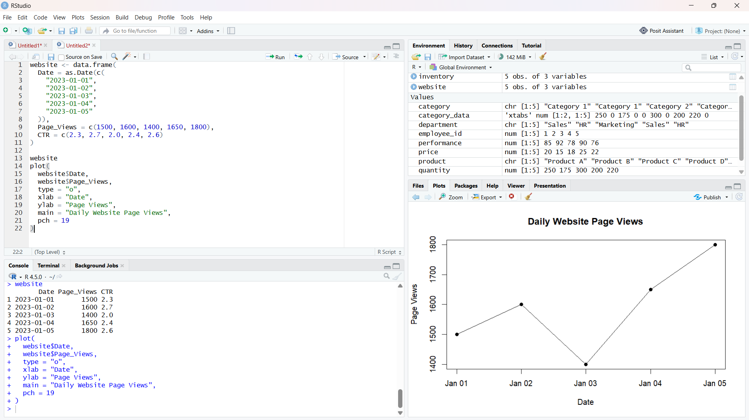

Output 1: Daily Page Views

Observation: Page views reach their maximum on January 5 and dip on January 3.

PROGRAM 2: Click-Through Rates by Day
Show the days with the highest click-through rates in a labeled bar chart.
R code
barplot(
top_3$CTR,
names.arg = top_3$Date,
xlab = "Date",
ylab = "Click-through Rate (%)",
main = "Top 3 Days by Click-through Rate",
col = "skyblue"
)

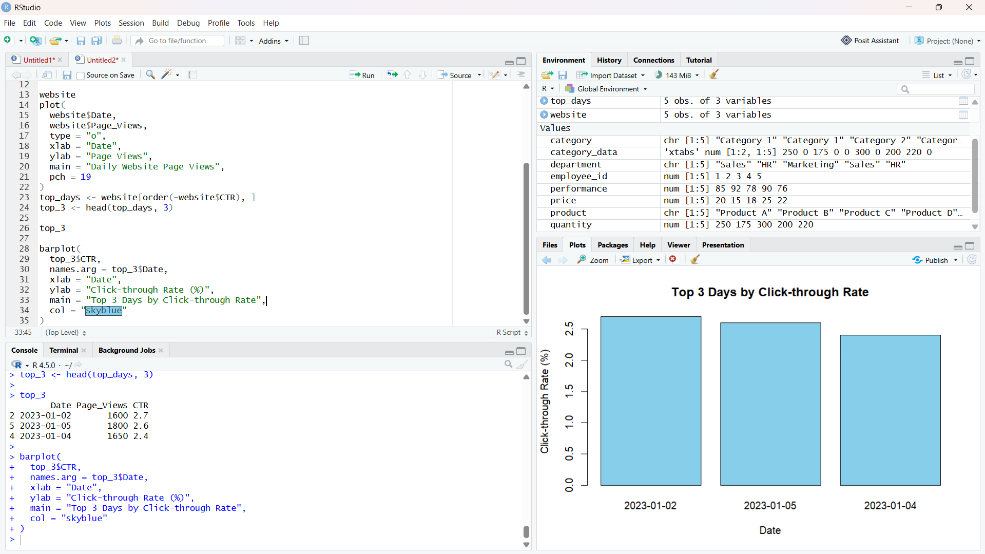
Output 2: Click-Through Rates by Day

Observation: January 2 has the highest click-through rate at 2.7%; January 3 has the lowest at 2.0%.

PROGRAM 3: Stacked Area of Website Interactions
Create a stacked area chart of likes, shares, and comments over time.
R code
library(ggplot2)
long <- reshape(dat, varying=c("Likes","Shares","Comments"), v.names="Count", timevar="Interaction", times=c("Likes","Shares","Comments"), direction="long")
ggplot(long, aes(Date, Count, fill=Interaction)) + geom_area() + labs(title="Website Interactions", x="Date", y="Interactions") + theme_minimal()

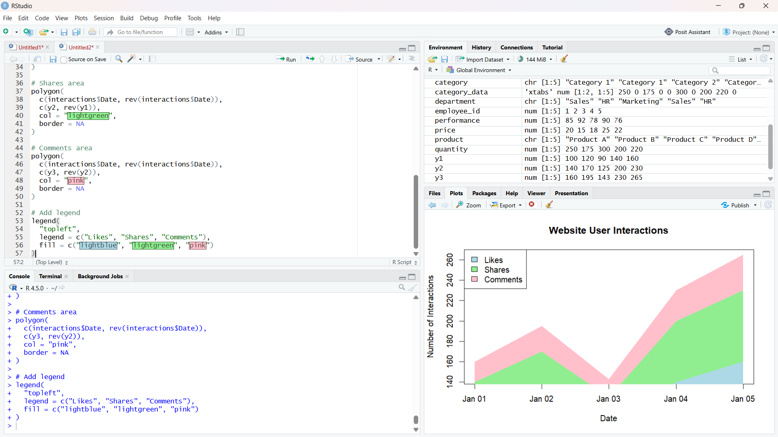

Output 3: Stacked Area of Website Interactions

Observation: Likes are the largest interaction count on every date. Interaction counts are illustrative because they are not supplied in the source.

PROGRAM 4: Website Traffic Dashboard
Build a Tableau dashboard with the daily page-view line chart and click-through-rate bar chart.
Tableau build steps
Tableau dashboard build
1. Connect to the website traffic table.
2. Build a line chart of Page_Views by Date.
3. Build a bar chart of Click_Through_Rate by Date.
4. Add both views to a dashboard and show a Date filter.

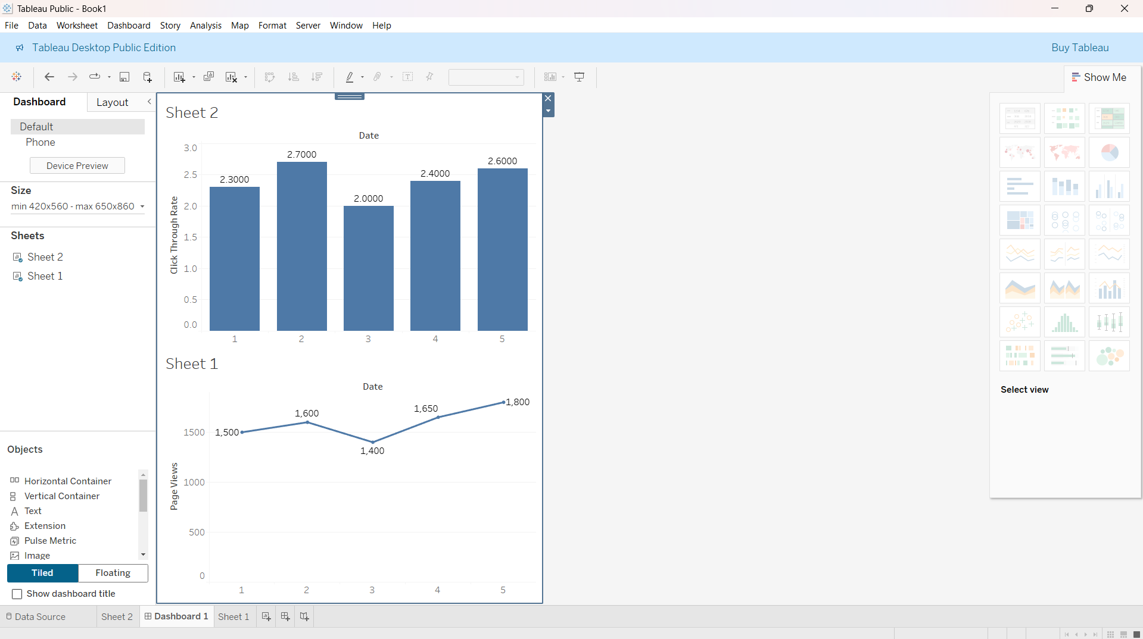

Output 4: Website Traffic Dashboard

Observation: The preview aligns the page-view trend and click-through rates by date; a date filter can coordinate both views.

Procedure
1. Review the dataset table and confirm any illustrative fields noted in the record.
2. Run the R setup block once, then run the requested program code.
3. Compare the output screenshot with the observation and replace illustrative values when actual data is available.
4. For Tableau tasks, connect to the displayed data and follow the dashboard build steps.

Result
The requested charts and dashboard views for Set 5 were prepared from the displayed dataset. Outputs include labels, short observations, and code or dashboard construction steps.

Key Functions Used
plot(), barplot(), hist(), boxplot(), table().

